Faculty of Arts and Sciences

Department of Computer Science

CMPS 297N – Mobile Development

Fall 2018, Dr. Farran

Mobile Development Project Plan

For the Group Term Project:

Connfa

Team Members:

Mohammed Houdeib

Omar Al Rachidi

Introduction

Project Overview

Connfa is an open source app for conferences and events aimed to make paper brochures a thing of the past. Imagine you're at a conference. A nice person at the reception desk checks your ticket and hands you one of these bright and shiny paper program guides. You walk off and start circling the events you want to attend. Everything goes fine until you miss the session you wanted to go to because you confused the date, or maybe you spent ages looking for the venue. To top it all off, you forget the brochure the next day and you're pretty lost. Sound familiar?

We added three new different features to the application, both in iOS and Android. Mohamad Houdeib handled the Android part of the project, while Omar Al Rachidi handled the ios part. The three new features were, Login and Register page, allowing attendees to send messages to each other and extending the user’s schedule for the event i.e. the session he/she is attending to sync with the phone calendar.

**Added Features**

Feature #1: Login and Register page

Feature #2: Allowing attendees to send messages to each other

Feature #3: Extend user’s schedule for the event i.e. the session he/she is attending to sync with the phone calendar

**Screen Mockups (iOS)**

* **Login and Register Page**

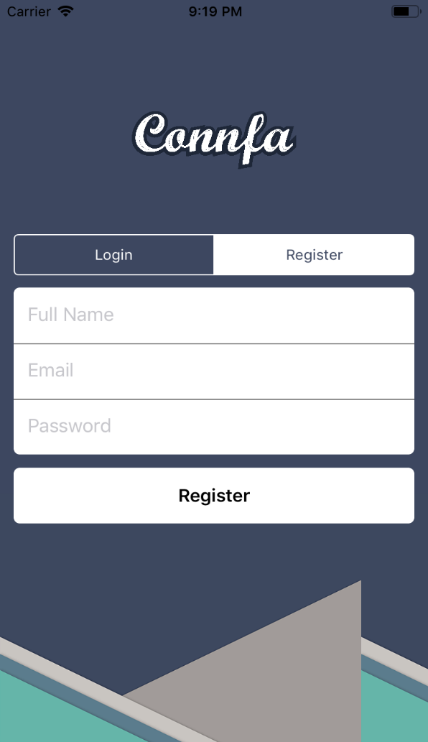 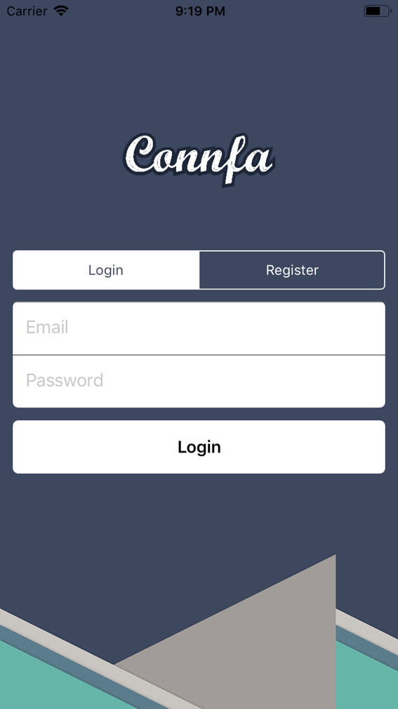

* **Side Menu with added features**

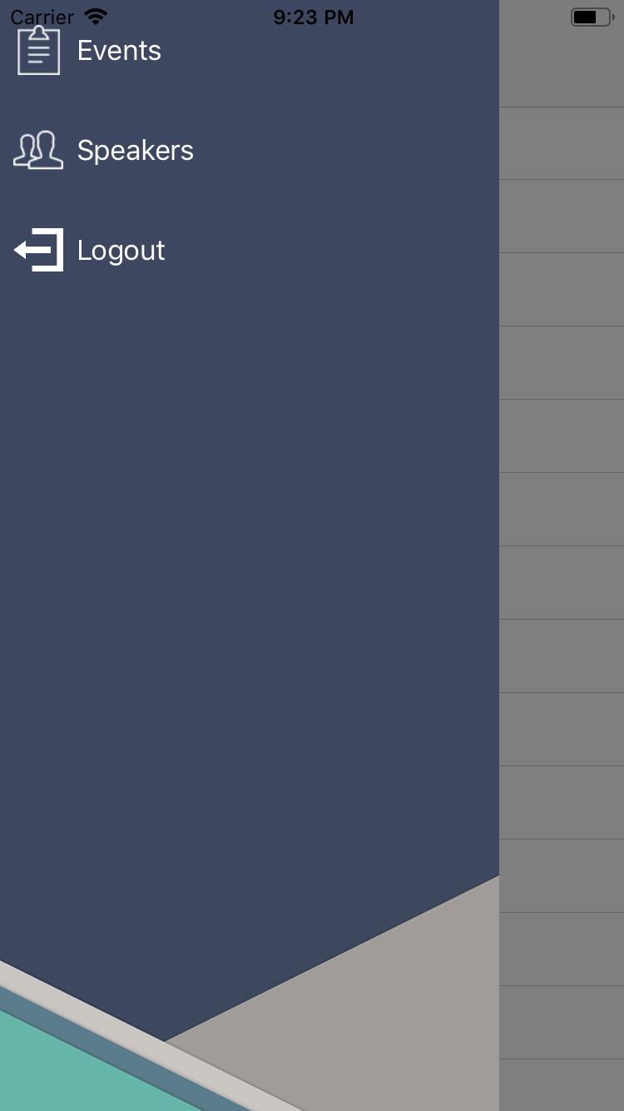

* **Speakers**

(Allowing attendees to send messages to each other.)

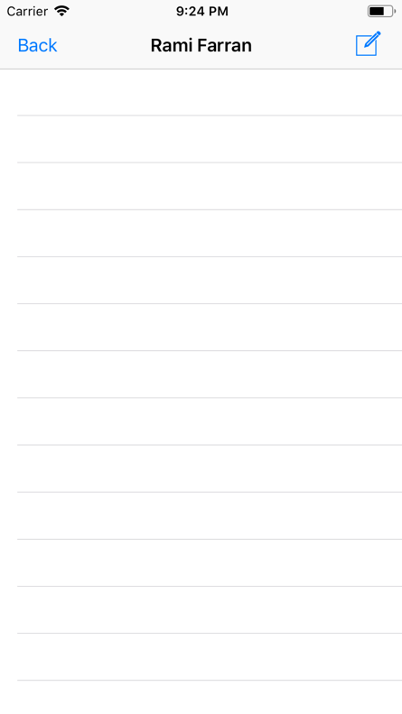 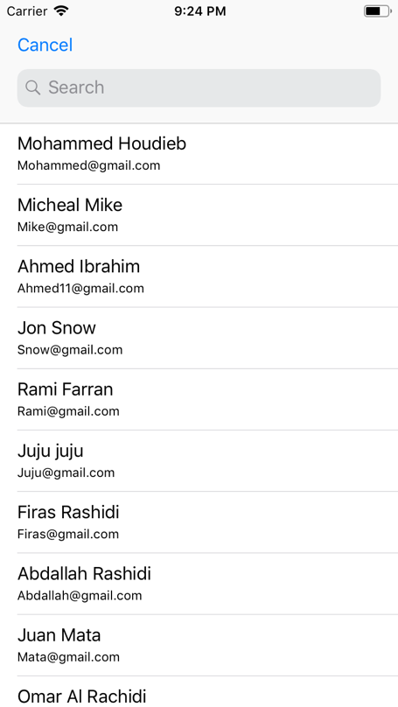

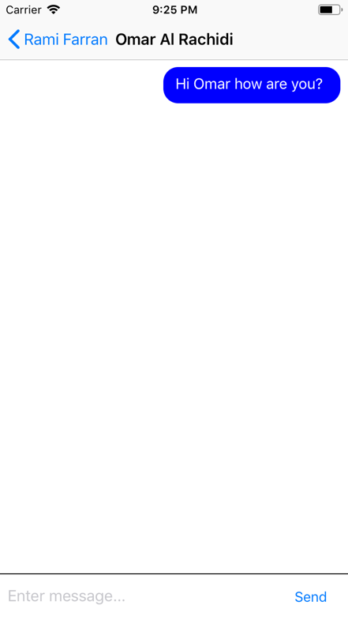 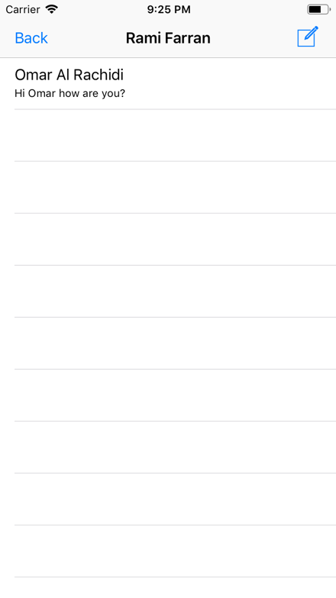

* **Events**

(Extend user’s schedule for the event i.e. the session he/she is attending to sync with the phone calendar)

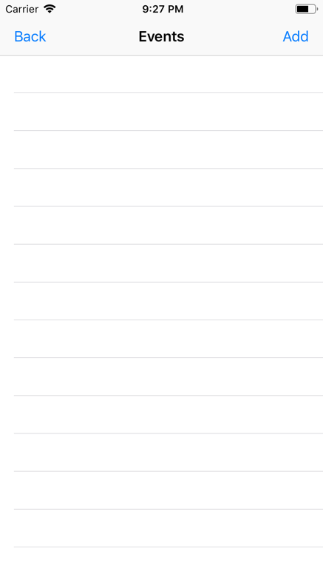 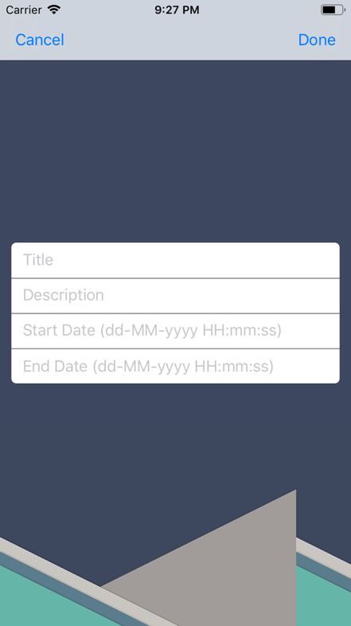

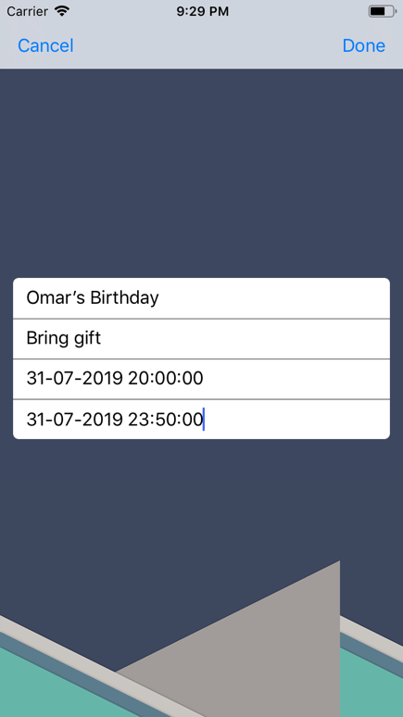 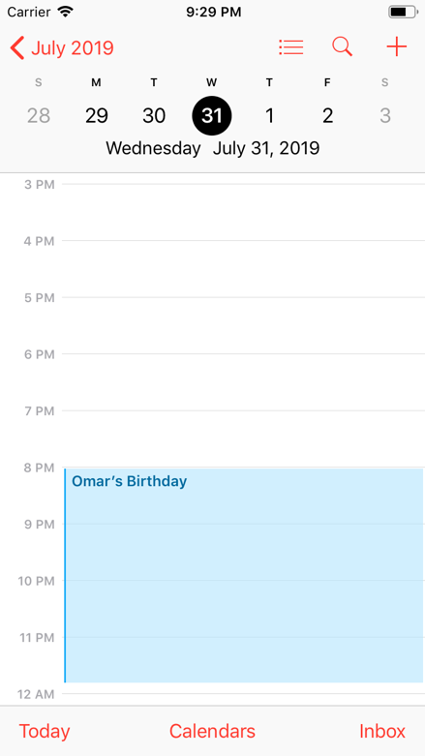

**Feature Explanation**

* **Login and Register Page**

For the Register page, the user is obliged to insert three fields, Full Name, Email and Password. For every field we have restrictions. If the user does not enter anything in those three fields, an alert will pop up to tell the user to enter the fields in full. If the user does not enter a proper email it will also alert the user to enter a reasonable email. Same thing with the password, the length of the password should be eight or the application will pop an alert to ask the user to insert eight characters.

The Login page has only two fields, Email and Password. When a user wants to login to his account, he needs to enter the email he registered with, as the email he registered in is saved in the database, so he can login with it. If the user did not enter his own email he registered with, he will not be able to enter.

* **Speakers**

The users that are registered are called speakers. In the speakers feature we have all the users that are registered in the application ready when pressed the new message button. The speakers feature is for the user to interact with each other. The users are now capable of sending message to one another. Sending messages will make communication much better between two speakers. The messages are also linked with the database. For every message you send to a colleague it is saved in the database with the time too.

* **Events**

Adding an event is upgraded to another level. When adding an event, the event is added only in the application. Now the event is linked with the phone calendar to alert the user before time. When adding the event, the user should enter four fields. The title of the event, the description, start date and end date. Start date and end date has an option of adding the time too. The user has an option of adding the event for a whole day or restrict the event for a limited time. On the phone calendar the user can turn the alert on before a desirable time. This new added feature will reduce the situations of not showing up to an event.